Steps for Downloading & Emailing forms from the

South Dakota VFW Website

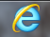
- Open your Internet Browser (Internet Explorer, Chrome, AOL) etc...

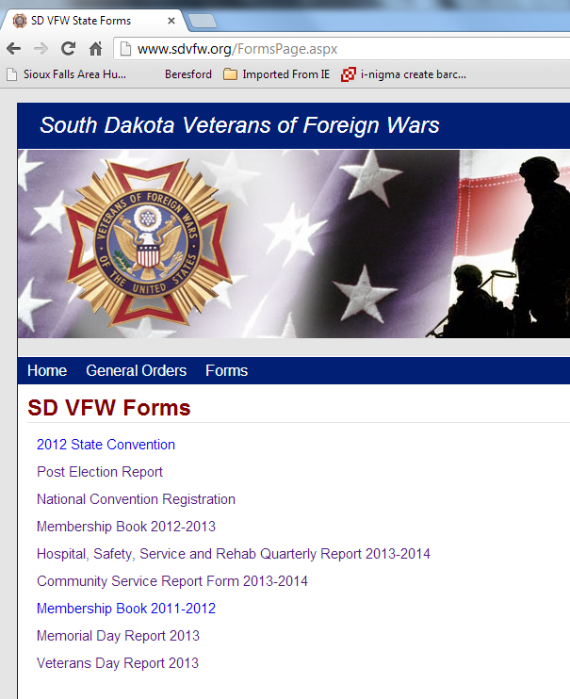
- Go to the website: www.sdvfw.org

- Select Forms

- Single-click the form you wish to open

- When the form is open - you will notice a small floating toolbar near the bottom right of your screen

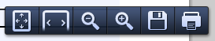

- Use this button to Save the form BEFORE you begin completing the form

- The File Name you selected will show up here. Select the location of where you wish to save the form. I would recommend putting the forms in the "My Documents" folder - possibly creating a special folder for the VFW. After double-clicking on the folder - then click save.
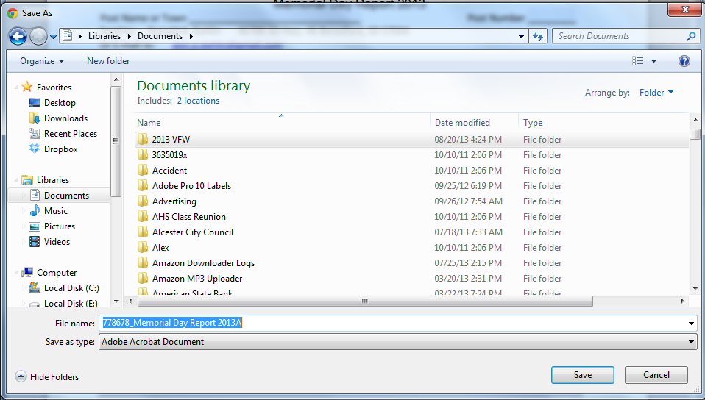
- The form will download so it will look something like this... Close all windows pertaining to sdvfw.org. Open documents folder and locate special folder assigned to VFW forms. Choose and double click the desired form to open and make entries.

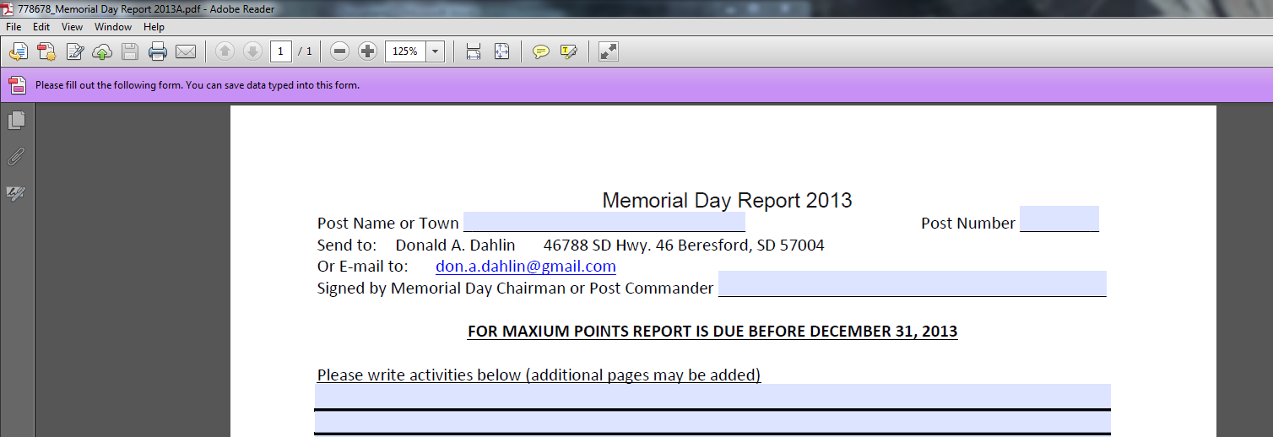
- You can change the form Magnification to make it easier to enter in your data. The screen magnification button is across the top of the screen. Begin entering in your data using you Tab key to move from box to box.
- Once the form is complete - select the Save button
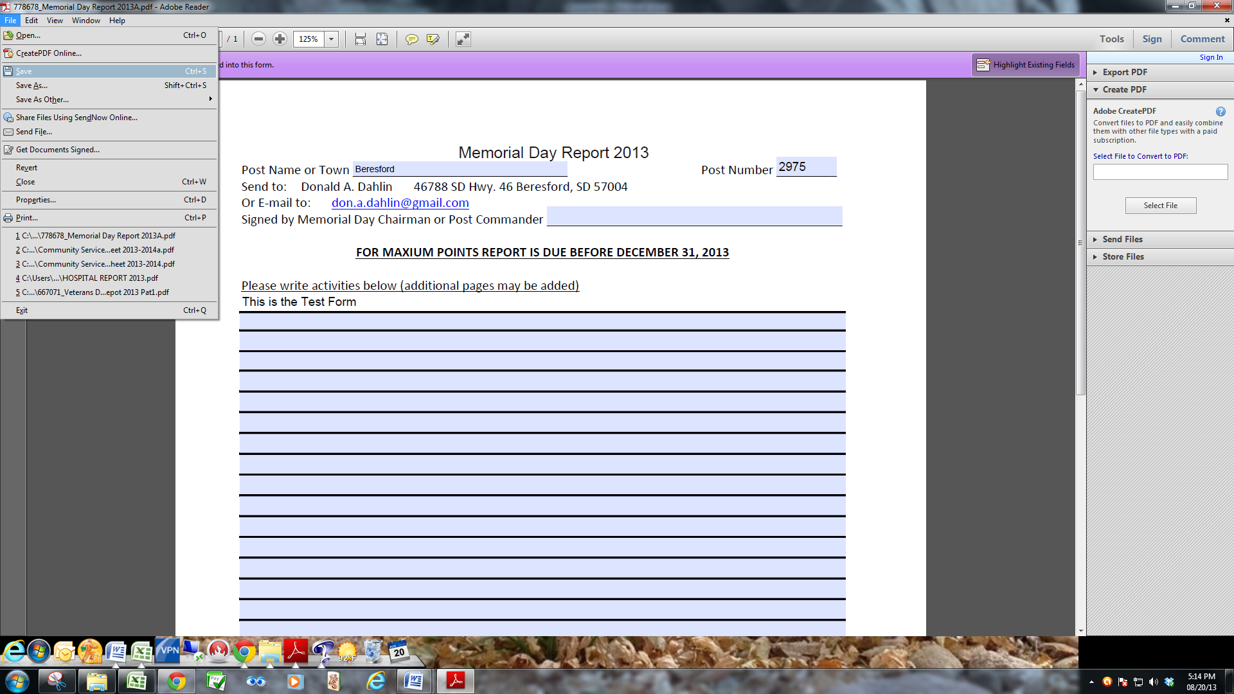
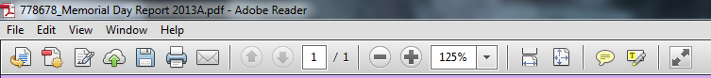
or

File - Save Method.

- Close all open Windows... Pertaining to sdvfw.org

- Get back into your email program.... Create an email - attach a file - which will be the completed form you just saved - Hit Send.

